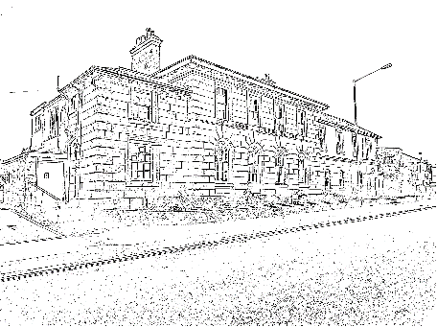
Camborne Community Centre
Booking Form
Organisation / Group
Contact name
Purpose of hire
Room required | Main Hall  Max 125 people | Room 2/3  Max 50 people | Room 4  Max 9 people | Room 5  Max 15 people | Room 9  Max 20 people
 | Room 15  Max 20 people | Large Annexe  Max 90 people |  | Small Annexe  Max 45 people
Date(s) of hire
Time of hire | From |  | To
Hirers Address
Contact number

Contact email

Information for hirers
Opening and securing rooms:
The building and rooms will be unlocked and available for the booking period, unless other arrangements are made.
Following the booking, we will ensure that the building is locked and secure.
Charges:
Charges for rooms vary with duration and the time of day.
We will always aim to work with hirers to achieve an affordable price, whilst still covering our costs.
For hirers other than charitable services, charges will be subject to V.A.T.
Facilities:
There are two basic kitchens, one on the ground floor and one on the first floor of the main building. There are kettles, a microwave, a fridge and crockery available.
In the annexe there are very basic facilities, with a kettle and fridge available.
There are toilets on the ground floor of the main building, including an accessible toilet and a unisex toilet on the first floor.
The two annexe rooms share toilet facilities.
All floors in the main building are served by a lift. There is a ramp to the large annexe.
Set up of rooms:
If there is a particular way that you would like the room to be set up, please let Mark know when you make your booking. We are happy to pack away all furniture at the end of your booking.
Cleaning:
All rooms will be cleaned before and after use, but please leave it as you would hope to find it.

Full terms and conditions of booking can be viewed on our website, or can be sent by post, please call to request a copy.

